**UTreatment**

**Verification test report (part 1)**

**Document reference number:** VeTR1

**Scope:** This document contains the test result from the first out of four verification test reports of the UTreatment system.

**Author:** Emma Rothmann, Katrine Stephansen, Louise Leonhard & Saaluja Sriharan

**References:** VeTP1

**Revision history:**

| **Revision** | **Revised by** | **Revision date** | **Description of changes** |
| --- | --- | --- | --- |
| 1.0 | Katrine Stephansen and Louise Leonhard | 29.04.2022 | First version |
|  |  |  |  |
|  |  |  |  |

## 

## Verification test result: Login

| **Requirement ID** | **Description of requirement** | **Status** |
| --- | --- | --- |
| FR8 | UTreatment skal kunne kommunikere med en personaledatabase indeholdende informationer omkring personalets loginoplysninger. | ✔ |
| FR9 | UTreatment skal kunne validere klinikerens loginoplysninger. | ✔ |
| FR15 | UTreatment skal kunne visualisere en fejlmeddelelse ved indtastning af ikke-valide loginoplysninger. | ✔ |

The results from performing the verification tests as described in VeTP1 are shown below.

*Main approach*

*Step 1: Step 2:*

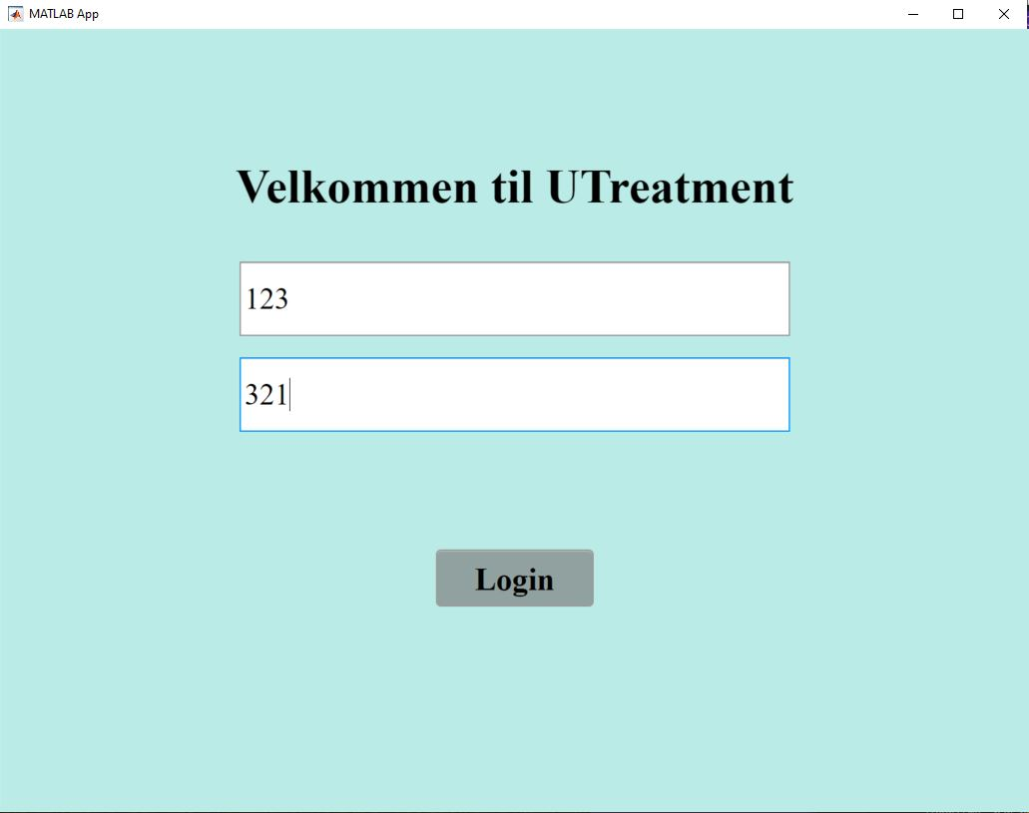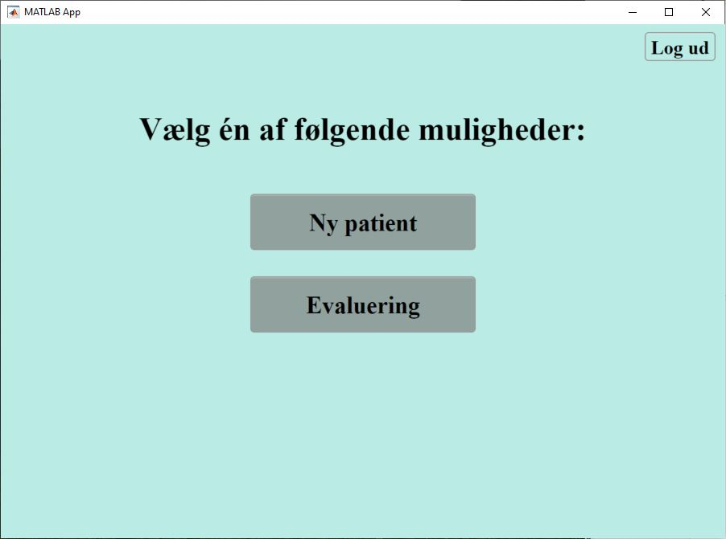

*Alternative approach*

*Step 1-2:*

